**HW to Chapter 4, 5 “One Hidden Layer” (combined for chapters 4 and 5)  
Non-programming Assignment**

**What is Hadamard matrix product?**

Hadamard product of two matrices is the by-component products of their elements,



**Describe matrix multiplication?**

Matrix (or dot) product of two matrices is the by-component products of their elements.

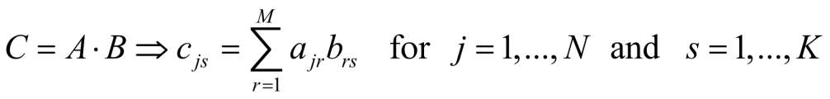

**What is transpose matrix and vector?**

1. A transpose of matrix A of size (N x M) is a Matrix AT of size M x N where aTkj = ajk.
2. Vector of size N is a matrix of size N x 1 (column) or 1 x N (row)
3. Vector AT (transpose) of a column-vector A is a row of components of vector A.
4. Vector CT (transpose) of a row-vector C is a column-vector of the components of row-vector C.

**Describe loss (cost or error) function in neural network**

The difference between the calculated and target (labeled) classification in logistic regression for a single pattern is known as a loss (error) function.

**Describe the foundations of neural network supervised training.**

1. Typically, the Perceptron with one or more hidden layers is referred to as a neural network.
2. An additional layer between the input X and the output layer helps improve classification capabilities of the Perceptron by providing nonlinearity in the regression separation.
3. Supervised training requires a labeled dataset. This dataset is divided into two parts: a training set and a test set.
4. Assessing the performance of the trained model on unseen data to ensure it generalizes well beyond the training set.

**Describe forward propagation and backpropagation.**

1. Forward propagation is the method of computing calculated output based on the input vector x, current weights w, and bias b.
2. Backpropagation algorithms are a family of methods used to efficiently train artificial neural networks (ANNs) following a gradient-based optimization algorithm that exploits the chain rule.
3. Learning Algorithm includes forward propagation, Loss Function, Backpropagation and Optimization.